PWILLETTON SENIOR HIGH SCHOOL

YEAR 12 PHYSICS

PRACTICAL ASSESSMENT Part 1
CIRCULAR MOTION

ANSWERS

An excellent Willetton High physics student conducted an experiment investigating circular motion.
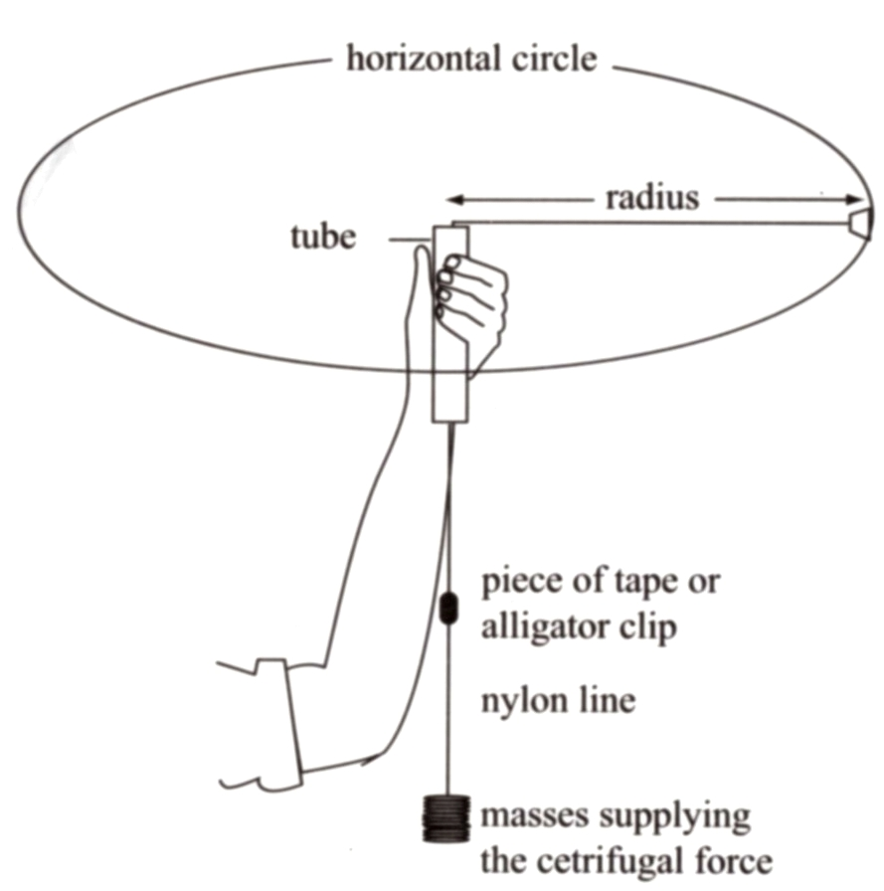

Rubber stopper

Masses supplying the centripetal force (F_{c})

The stopper was whirled in a circle, and the radius of the circle was kept at a constant value
of: 0.600 m

The results obtained were as follows:
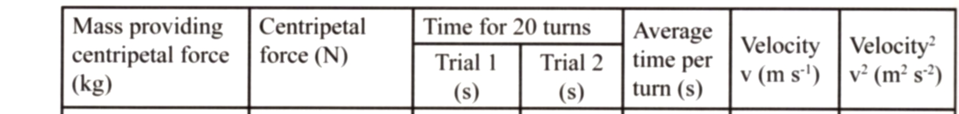

0.200 1.96 15.2 15.1 0.757 4.98 24.8

0.250 2.45 14.2 13.1 0.683 5.53 30.5

0.300 2.94 12.9 11.7 0.615 6.13 37.6

0.400 3.92 10.8 10.3 0.528 7.14 51.0

0.450 4.41 10.1 10.2 0.508 7.42 55.1

1.0 Complete the table of results. (1/2 marks per fully correct column, total 2 marks)
1 mark: labelled scales

1 mark: accurate scales and plotting

1 mark: Line of best fit

-1 if through (0,0)
Note:

The line should not be drawn through (0.0)
according to WACE and this point should not be used to calculate slope.
Only lose a mark for drawing graph to (0,0),
not for using in calculation

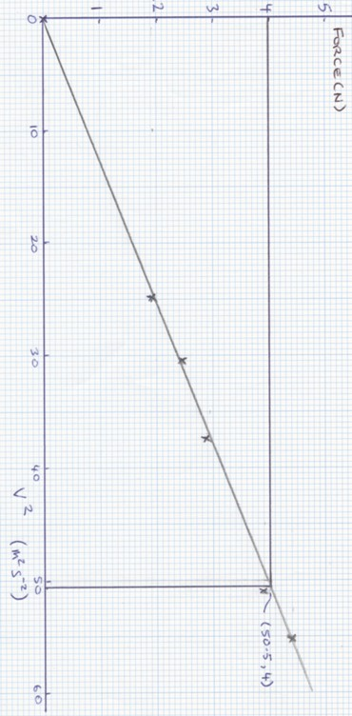

- On the graph paper provided, plot the data of centripetal force versus velocity squared.
- marks)

3.0 Use this graph to determine the mass of the rubber stopper
(Show working here.)

Slope from graph = 4 – 1.1 = 0.0805 Nm⁻²s² Kgm⁻¹ (1 mark)
51 - 15

Since F = mv² /r

Slope = m/r (1 mark)

m = slope . r = 0.0805 x 0.6 = 0.0483 kg

Hence mass of stopper is 48g (2 marks : within 2g, 1 mark within 5 g
-1 mark if more than 2 sig figs)

4.0

A

Θ B
F_{c}
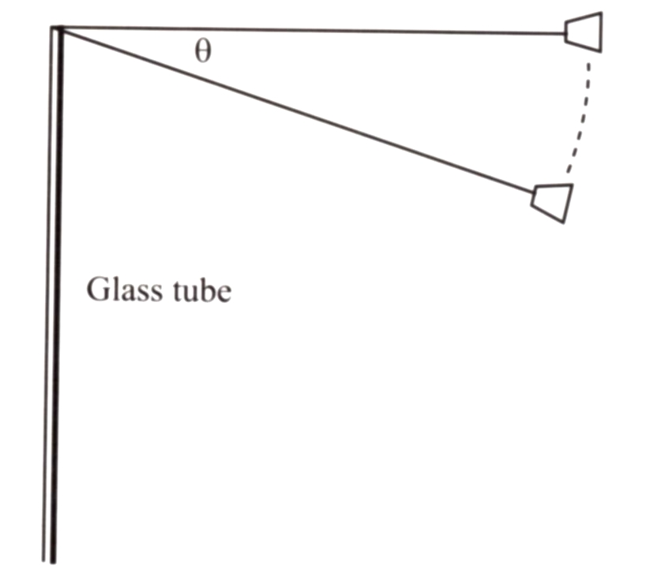
If the string sags as shown:
Determine the expression for the force which provides the centripetal acceleration of the stopper when it is rotating at position B.

Copper tube

cos Θ = Fc
mg F = mg
(Note: m is total mass
of suspended weights)

F_{c} = mg cos Θ (m is mass of weights supplying F_{c}) (1 mark)

